Centerville School District Athletic Booster Club VOLUNTEERHUB Instructions

EVERYONE MUST CREATE A NEW ACCOUNT!!
- Go to: http://athleticboosters.volunteerhub.com/Events/Browse.aspx
- Click the REGISTER button and follow the prompts
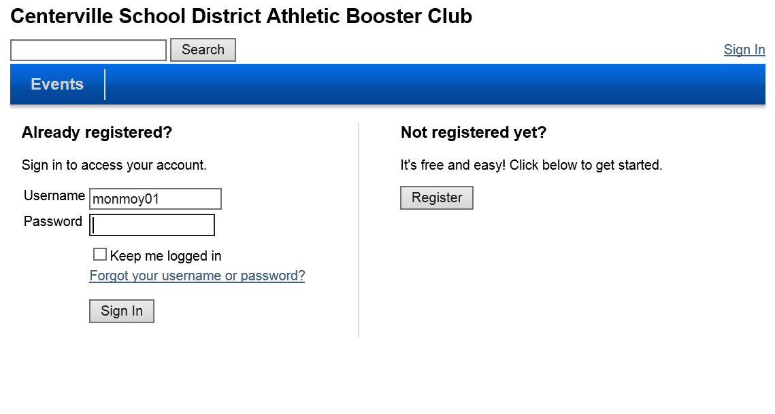

- Select a user name and password and click next
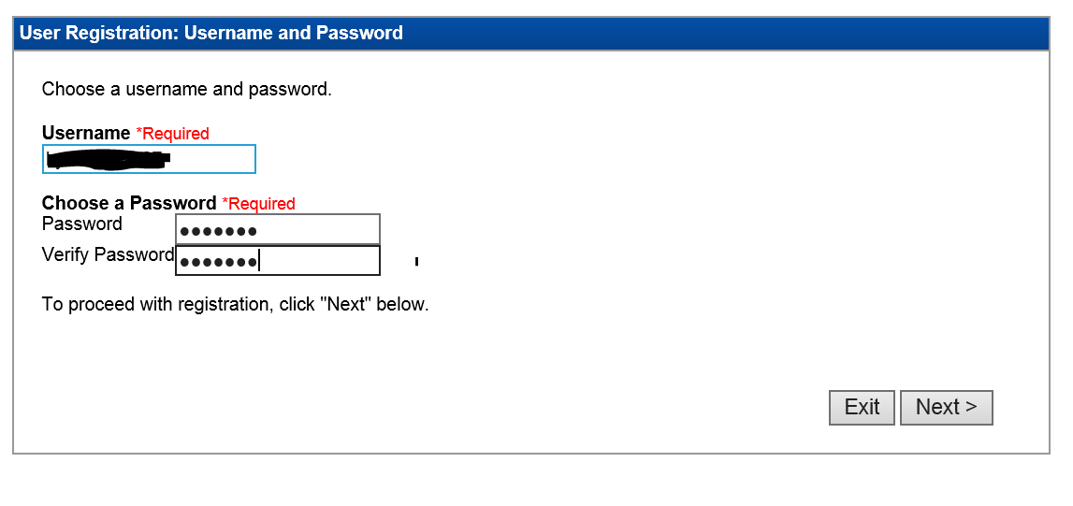

- Select the groups that apply to you. At a minimum include the following groups:
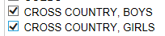
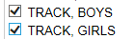
- Enter your user details and click next.
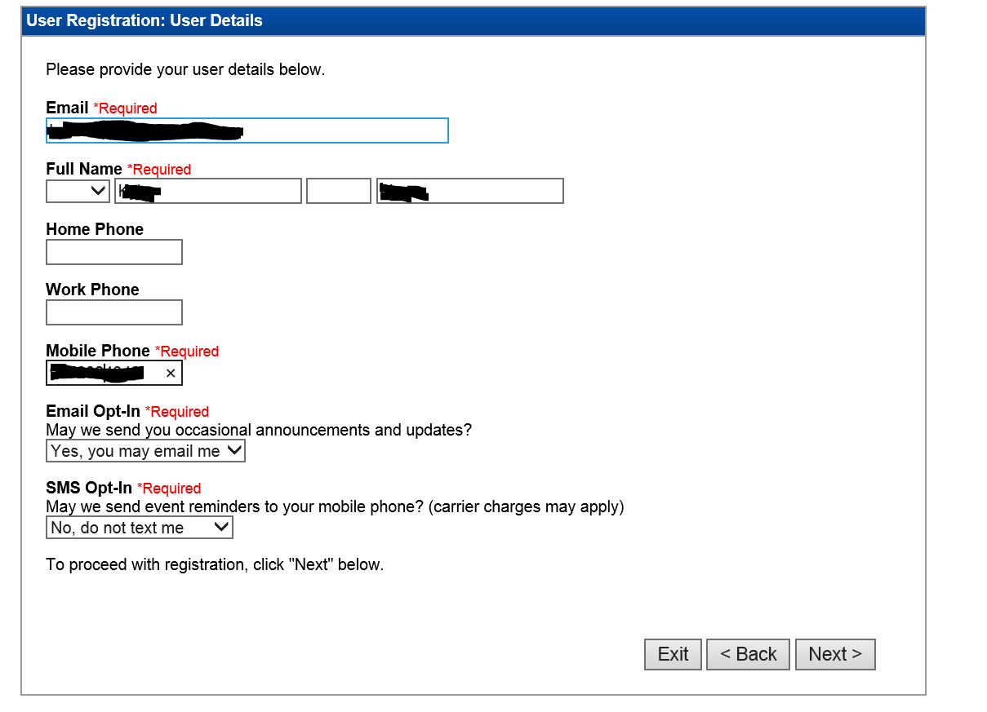

- Click next and confirm your information. Click back to make any edits.
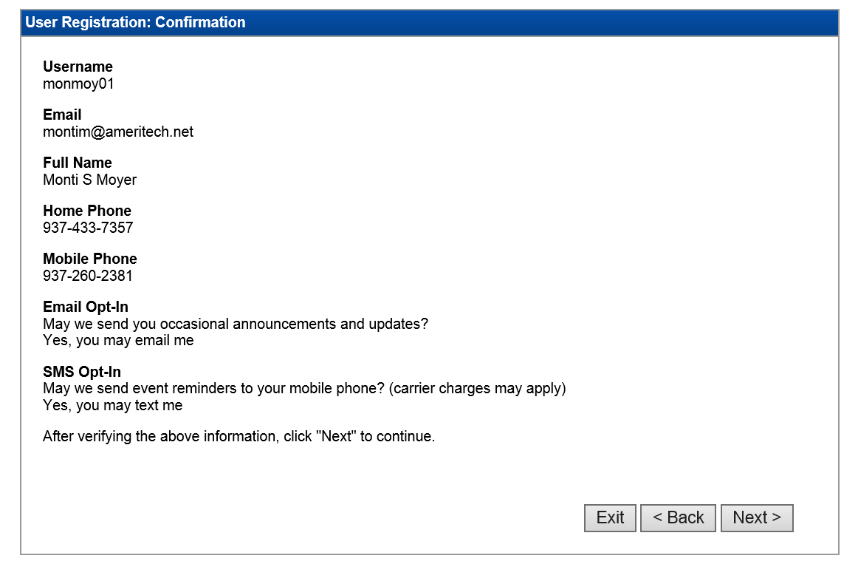

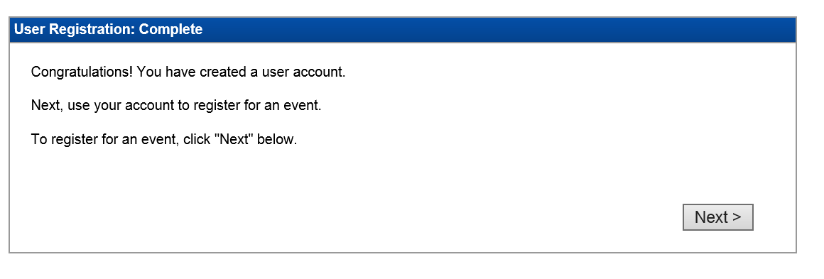
- You should now be able to see events that are available to work.
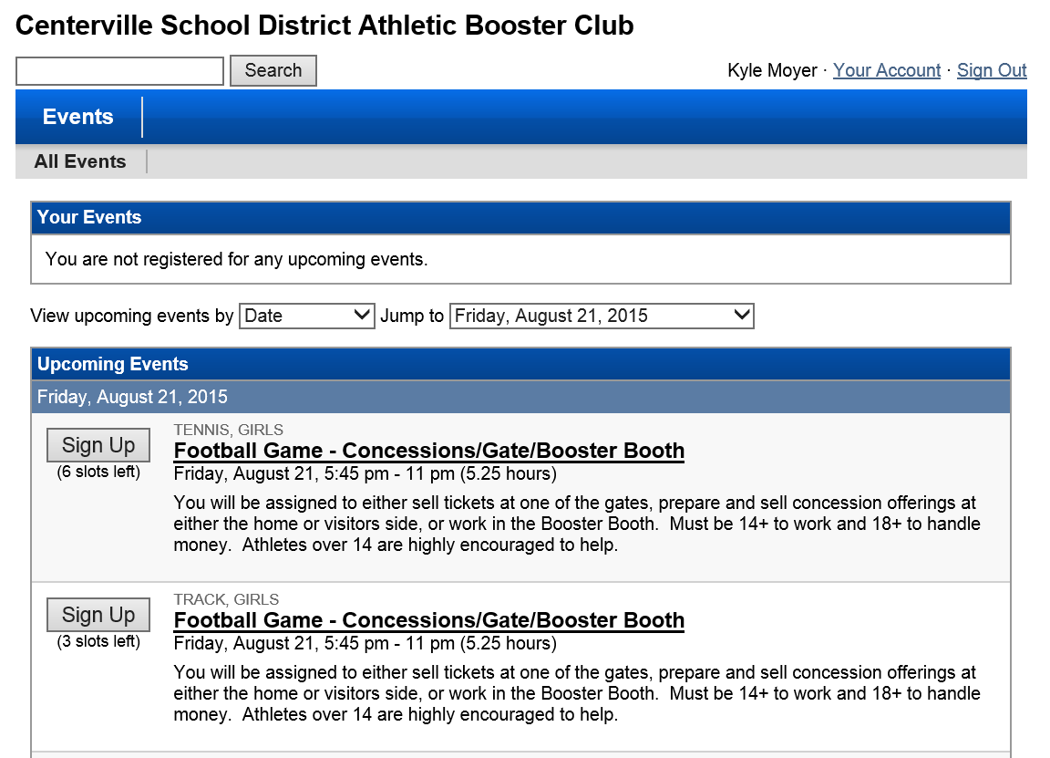

- Sign up in any “OPEN” slots and a reminder will be sent to your email a few days prior to the event
To Make Changes to your registration:
- Click “Your Account”
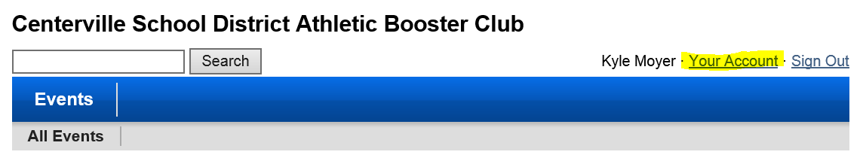

- Verify your account with your user name and password. By default it is already auto-populated you should be able to click next. (Enter your information if it isn’t auto-populated.)
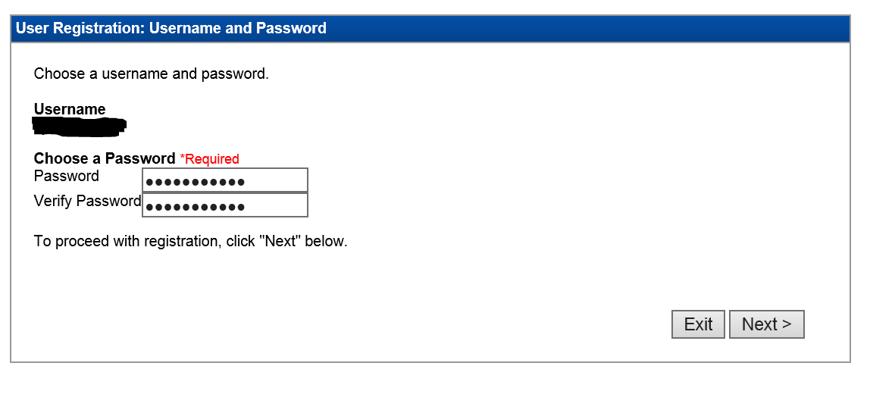

- Make any updates to your user registration groups and click next.
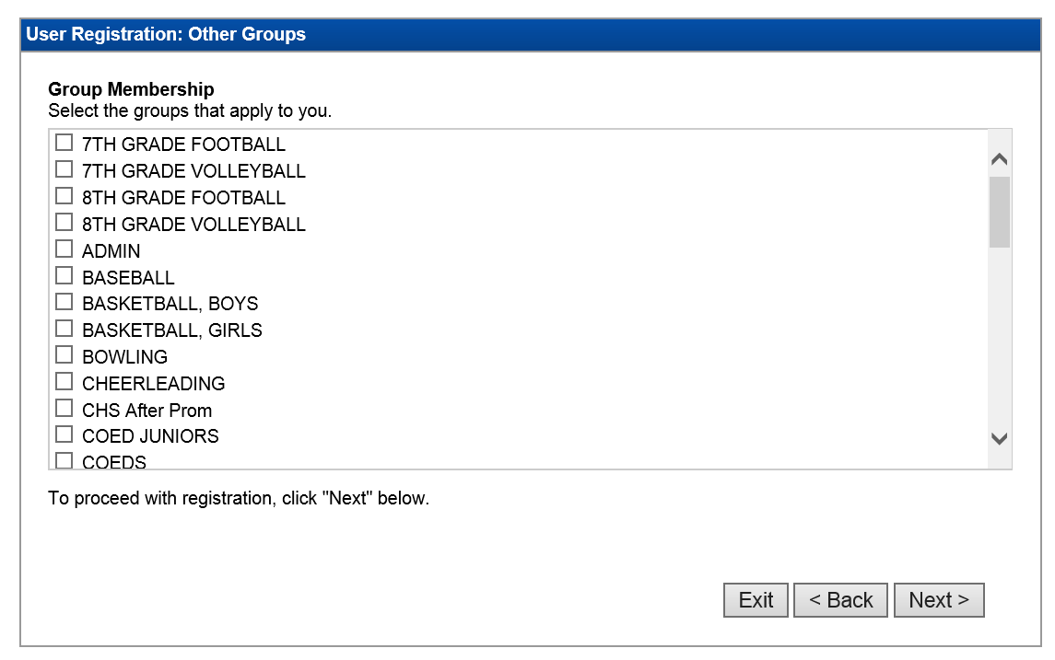
- Make any edits needed to your User Details and click next.

- All information is updated.
Questions regarding Volunteerhub, contact Chris Lamier at chris.lamier@gmail.com or Monti Moyer at monti.moyer@ameritech.net

