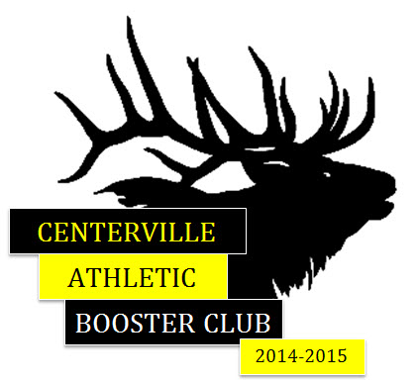
2017-18 Centerville Sports Program
Parent Ads

Parents are now able to purchase “Happy Gram” ads for their student athletes in the Sports Programs. Put your athlete’s photo along with a note of encouragement or congratulations in this year’s sports program! These ads can be of one student, student groups, or whomever you would like to send words of encouragement to!!

Your Booster Representative is:

Name _Holly Hippenmeyer____________________________
Phone _291-2130________________________________________
Address: _2460 Mill Trace Lane, 45458_________________
E-Mail: _hollykhipp@aol.com__________________________
Sport: _Girls Cross Country____________________________

Your ad will be included in the program for the season your student plays. Rates are listed below. Return this form with your check payable to Centerville Athletic Booster Club to your booster representative above by August 11, 2017.

The completed ad must be submitted electronically to your Booster Rep at the above e-mail address. The preferred format is a PDF 300dpi. Your file name needs to include your student’s name, size, and color of the ad in it. Please make sure the art work is not locked and that it appears exactly as you want it to in the program. Boosters do not create the ad; that is up to each person purchasing the ad.

Please check one:

______$45.00 for small COLOR ad (business card size)
______$65.00 for ¼ page COLOR ad
______$100.00 for ½ page COLOR ad
_____$175.00 for full page COLOR ad

______$35.00 for small Black and white ad (Business card size)
______$55.00 for ¼ page Black and white ad
______$90.00 for ½ page Black and white ad
_____$150.00 for full page Black and white ad

Your Name: _____________________________________________
Your Student’s Name __________________________________ Sport ___________________________________
Address: _________________________________________________
City, State, Zip: ________________________________________________________
Phone: _________________________________ Email:____________________________________________

